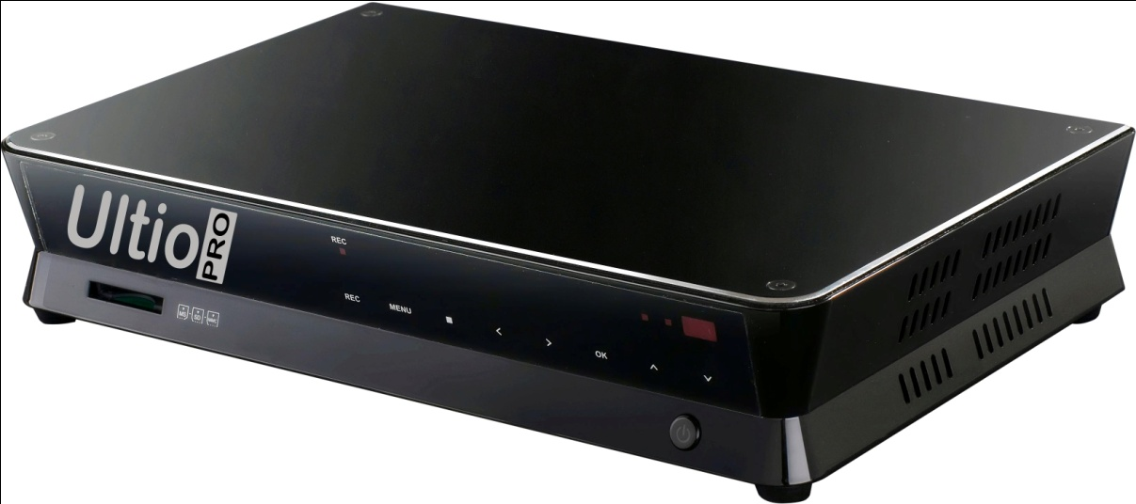

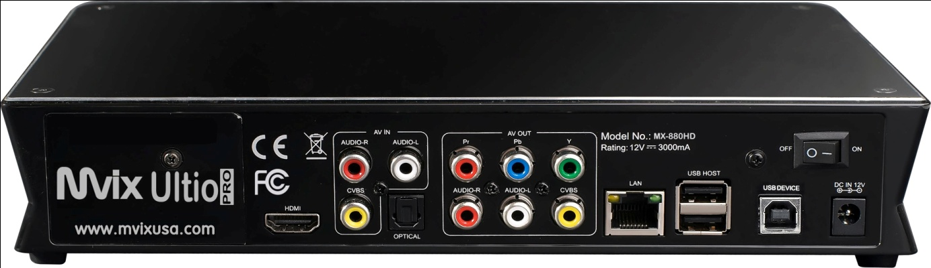

Mvix Ultio Pro Format Support: Video Formats and Codecs
File Type | File Extension | Video Codec | Audio Code
MP4, MOV | .mp4, .mov, .xvid, .m4v | Divx 3 / 4/ / 5/ / 6  Motion JPEG  MPEG-4 SP / ASP (Xvid)  MPEG-4 AVC (H.264) | LPCM, uLaw, aLaw  MPEG-Audio  HE-AAC, LC-AAC  Dolby Digital Plus  Vorbis  MS-ADPCM
AVI | .avi, .divx | MPEG-1  Divx 3 / 4/ / 5/ / 6  Motion JPEG  MPEG-4 SP/ASP (Xvid)  MPEG-4 AVC (H.264)  VC-1 | LPCM, uLaw, aLaw  MPEG-Audio  HE-AAC, LC-AAC  Dolby Digital Plus  DTS  Vorbis  MS-ADPCM  WMA, WMA Pro
Minus VR |  | MPEG-1  MPEG-2 | LPCM  MPEG-1 Layer 2
DVD Video | .iso | MPEG-1  MPEG-2 | LPCM  MPEG-1 Layer 2  DTS
ASF, WMV | .asf, .wmv, .xvid | Dvix 3 / 5  MPEG-4 SP/ASP (Xvid)  VC-1  WMV | LPCM  WMA  WMA Pro  ADPCM
FLV | .flv | H.263  MPEG-4 AVC (H.264) | LPCM  MPEG-AUDIO  HE-AAC, LC-AAC
MKV | .mkv, .xvid | DIVX 3/4/5/6  MPEG-1  MPEG-2  MPEG-4 SP/ASP(XviD) | LPCM  MPEG-AUDIO  Dolby Digital Plus  HE-AAC, LC-AAC  DTS, Vorbis  MS-ADPCM  WMA, WMA Pro
RM, RMVB | .rm/.rmvb | RV8,RV9 | COOK  HE-AAC, LC-AAC  RA-Lossless
TS | .ts/.m2ts/.mts/.tp/.trp | MPEG-1  MPEG-2  MPEG-4 AVC(H.264)  VC-1 | LPCM  MPEG-AUDIO  Dolby Digital Plus  HE-AAC, LC-AAC  DTS, TrueHD
DAT, MPG, MPEG | .dat, .mpg, .mpeg | MPEG-1  MPEG-2 | LPCM  MPEG-AUDIO  HE-AAC, LC-AAC  DTS
VOB | .vob | MPEG-1  MPEG-2 | LPCM  MPEG-1 Layer2  DTS

Mvix Ultio Pro Format Support: Audio Formats and Codecs
File Type | File Extension | Version Support
MPEG-1 Layer 3 | .mp3
WMA | .wma, .asf | WMA 7~9.1
WMA pro | .wma, .asf | WMA pro 9.1
MPEG-1/2 Layer 1/2 | N/A  (included in video only) | MPEG 1/2
WAV | .wav
MKA | .mka
LPCM | N/A  (included in video only)
ADPCM | N/A  (included in video only) | Microsoft ADPCM  G.726
AAC | .aac, .mp4 | MPEG-2/4 LC/HE profile  AAC+ ver. 1/2
OGG Vorbis | .ogg | Up-to-date
Dolby Digital | N/A  (included in video)
Dolby Digital Plus | N/A  (included in video)
DTS | .wav  (or included in video)
DTS-Master Audio | N/A  (included in video only)
RA-COOK | .ra, .rm, .rmvb
RA-lossless | .ra, .rm, .rmvb
FLAC | .flac
BBE | N/A | Surround
SRS | N/A | Surround

Mvix Ultio Pro Format Support: Image Formats and Codecs
File Type | File Extension | Version Support
JPEG | .jpg/.jpeg
BMP | .bmp
PNG, GIF | .png, .gif
TIFF | .tiff

Mvix Ultio Pro Format Support: Subtitle Formats
File Type | File Extension | Version Support
SubRipper | .srt
MicroDVD | .sub
SAMI | .smi
VobSub | .idx + .sub
SubStation Alpha | .ssa
Advance SubStation Alpha | .ass
DVD Subtitle | N/A | DVD Video
DivX Subtitle | N/A | DivX Ultra / DivX HD

Mvix Ultio Pro Format Support: Video Recording
File Type | File Extension | Version Support
MPEG 2 | .mpg

